**USER EXPERIENCE METHODS DESIGN**

**What The Fish**

www.fishingbuddy.com.sg

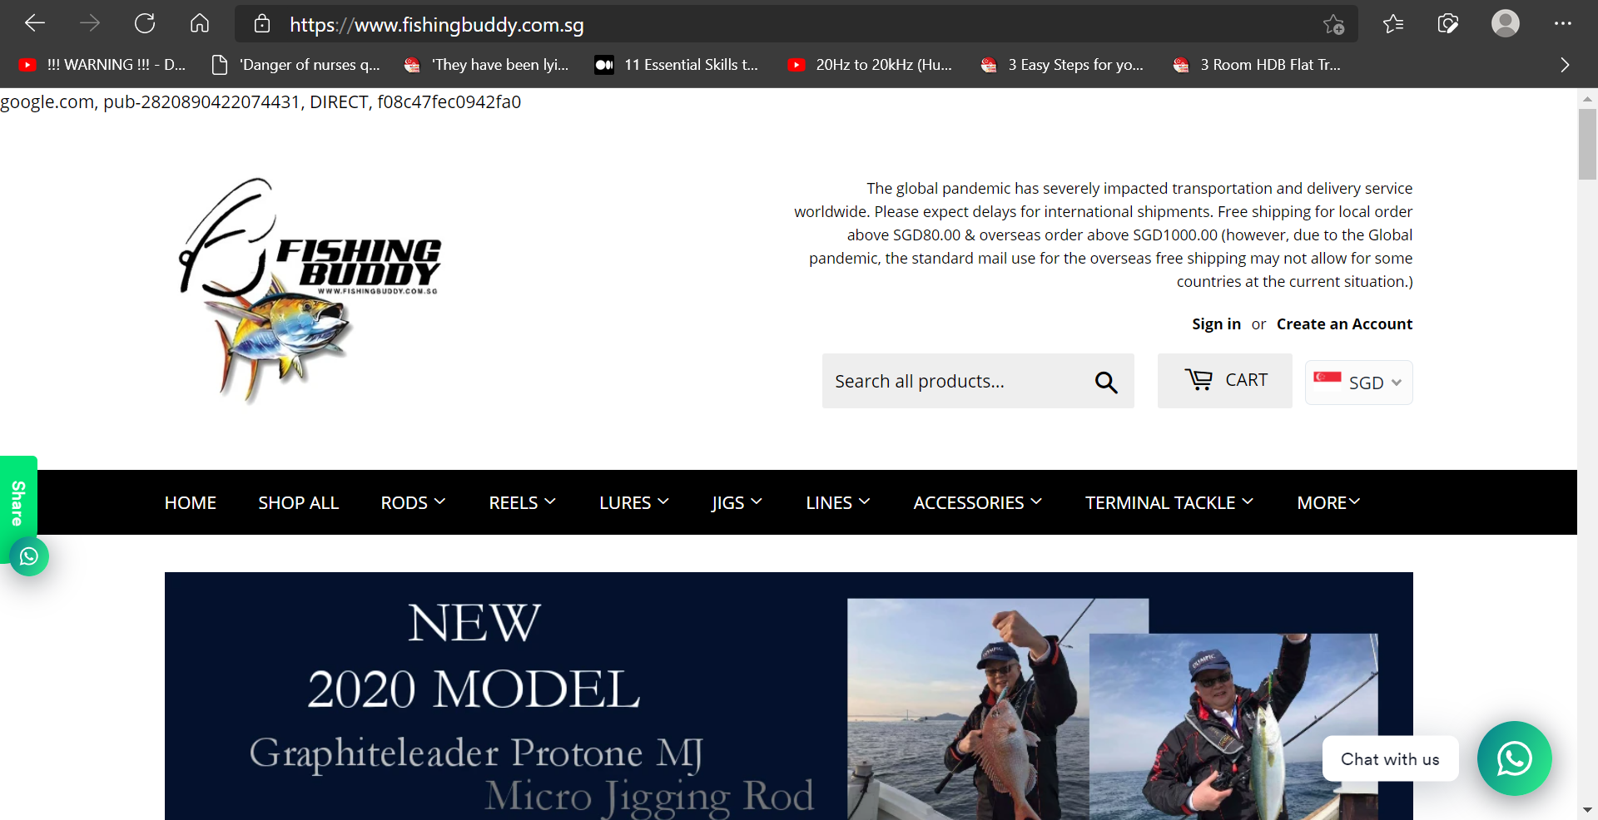

**1. Brief Introduction:**

* Fish & Tackle e-commerce web sites in Singapore.
* For the fishing enthusiast, who frequently shouts “What the fish!” when fishing.

**2. Business Goal:**

* These web sites focus solely at providing fishing equipment, & nothing else.

**3. Problem Definition:**

* As such, User experience is secondary here.
  + Inconsistent functional features / flow.
  + Users may find it difficult to quickly complete their purchases.

**4. Context of Use:**

* Users usually just visit website, buy items & leave.

**5. User’s Expectations:**

* Easy to make cheap discounted purchases,
* Any new products?

**Competitor Analysis: (1)** https://www.lurehaven.com.sg/

1. Introduction, Target Audience, Unique Selling Point:

* Exactly the same as [www.fishingbuddy.com.sg/](http://www.fishingbuddy.com.sg/)

2. Key Strengths:

* Header section is SMALLER.
* Smaller banner pictures that do NOT go beyond viewport.
* Has “Favourites” icon, (🎔).
* "Use coupon code" appears EARLY at start of shopping cart page, instead of at final payment page.
* "Add to cart" button NEXT to every products in "Product item" page.

**Competitor Analysis: (1)** https://www.lurehaven.com.sg/

2. Key Strengths: (continue)

* Provides ADDITIONAL filter choices to mitigate the long list of products

(category, brands, product type, sort by).

* Navigation header bar REMAINS at the top of every web page.
* Explains PURPOSE of registering with website; shop faster, updates on orders made, track previous orders.

3. Key Weaknesses:

* Favourites & cart icon doesn't update item counts in REAL TIME, updates only when click on that icon.
* Carousel banner is NOT SELECTABLE, so is purely for advertisement purposes only.

**Competitor Analysis: (2)** https://www.eastackle.com/

1. Introduction, Target Audience, Unique Selling Point:

* Exactly the same as [www.fishingbuddy.com.sg/](http://www.fishingbuddy.com.sg/)

2. Key Strengths:

* BIG colourful pictures of categories to entice Users.
* "Add to cart" button NEXT to every products in "Product item" page.
* Displays "Related products" at the bottom of "Product item details" page.
* Other customer TESTIMONIALS in footer.

**Competitor Analysis: (2)** https://www.eastackle.com/

3. Key Weaknesses:

* Small fonts used everywhere.
* Lots of unused white empty background on webpages.

**Competitor Analysis: (3)** https://redtackle.com/

1. Introduction, Target Audience, Unique Selling Point:

* Exactly the same as [www.fishingbuddy.com.sg/](http://www.fishingbuddy.com.sg/)

2. Key Strengths:

* Dynamic menu bar on left hand side of web page, gives a DIFFERENT look & feel.
* “Product item details” page includes links to Youtube videos, adds a STORY, instead of just plain selling of items.

**Competitor Analysis: (3)** https://redtackle.com/

3. Key Weaknesses:

* Header / navigation bar do NOT remain at the top of every web page.
* Carousel banner is NOT SELECTABLE, so is purely for advertisement purpose only.
* Product item pictures are TOO BIG, causing User to scroll down webpage a lot to see the products.
* Checkout page looks almost the same as checkout page from fishingbuddy.com.sg, who COPIED who?

**Competitor Analysis:**

Insights:

* Competitors makes good use of appropriately sized pictures, easily available navigation bars. (attentive INFORMATION ARCHITECTURE)
* Has convenient (INTUITIVE & FUNCTIONAL NAVIGATION) “Add to cart” buttons next to product items, so Users can quickly purchase products & leave.
* Includes User testimonials & Story (related Youtube video links) to PERSONALIZE a bland e-commerce web site.
* Includes “Related products” to ENTICE Users to buy more.
* Includes additional product display filters (Sort-by), that helps to manage selective viewing of many products on the web page. This improves overall User experience.

**Name:**



Mr Goh Trendy

Small business owner

“Who wants to see my prized catch?”

The thrill of catching prizes like rare fish & gf

Middle income salary man, monthly paycheque slave

**Demographics:**

30 years old

Male

More than sufficient disposable monthly income

Married

|  |  |  |  |  |
| --- | --- | --- | --- | --- |
| **Goals & Concerns:** | | | | **How we can help:** |
| 1. To show off prized trophies to friends.  2. Not enough new products in website; only update once a month.  3. Likes to see what other customers buy also.  4. Prefers to see a professional page, without the funny text at the top of the webpages.  5. Need to press many buttons, jump from page to page, then can finally see all the items.  6. Likes to save money, with discounts. | | | | 1. Provide quality fishing equipment, to ensure reliable catch of fish, helps to ensure caught fish don't jump back into the sea.  2. Suggest to Business owner to source for new products regularly.  3. To record history of customers purchases.  Based on what this customer selects,  to display what other customers bought together with this selection, as a recommendation eg. "Products related to this item".  4. Remove/hide google tracking text at top of web pages, for a professional look.  5. Provide drop down list to show "number of items per page".  6. Allow customer to enter discount coupon codes in Cart page. |
| **User Story: Goh Trendy** | | | **User Scenario** | |
| As a … | I want to … | So that … | Scenario 1 | |
| Middle income salary man | Share with my friends, all my trophies | They can see how successful I am | After having worked so hard, climbing the corporate ladder, earning lots of money, now I want to show my friends how successful I am. Previously I managed to catch big, rare fish on our fishing boat trips, but several of my prized fish jumped back into the sea. All because of my lousy fishing equipment. I need reliable, good quality fishing equipment to help me hang on to my trophies. So that I can show off to my wonderful friends. Nothing but the best equipment that my money can buy, for me. | |

User Journey: **Goh Trendy** **(BEFORE)**

|  |  |  |  |  |  |
| --- | --- | --- | --- | --- | --- |
| Happiness | Angry face with solid fill with solid fill | Angry face with solid fill with solid fill | Angry face with solid fill with solid fill | Angry face with solid fill with solid fill | Angry face with solid fill with solid fill |
| Touch points | Web pages has funny text on top | New arrivals page, displays a few items at a time | Select item to buy | Add to Cart page | Checkout page |
| Pain points | Looks unprofessional | Have to click many buttons to see all the new arrival items | Single item picture can be bigger | Small fonts, lots of white background space, Cart pop up window exceeds screen page for just 2 items selected | What to select? Enter contact info / continue to shipping / 1 of the above payment services |
| Support | To hide “google tracking” text | To provide drop down list to allow more display choices "number of items per page | To increase single picture size to use up more of the empty page | To increase font size, minimize white empty background of Cart page | To simplify layout |

**Name:**



Mr Relax Joe (Design persona)

Retiree

Wants to hang out with friends, reminisce about old times,

looks for bargain equipment, but value for money also

**Demographics:**

55 years old

Male

Has more than sufficient retirement funds

Married

|  |  |
| --- | --- |
| **Goals & Concerns:** | **How we can help:** |
| 1. Values bonding time with friends without spouse.  2. Navigation menu bar not easily accessible.  3. Banner too big, occupy beyond screen page.  4. The number boxes (at the bottom of the page) to go to different product pages are quite small;  difficult to point with finger.  5. Great if can pay online & collect items at retail store.  6. Would like to see what others catch (social media). | 1. Provide reliable quality fishing equipment that doesn't breakdown so he can focus on bonding sessions.  Introduce friends to spouse as distraction.  2. To fix navigation bar at the top of every web page that customer visits.  3. Reduce banner size to half screen page.  4. Increase size of page number selection boxes.  5. To include "self-collect" option in shopping cart page.  6. Advise customer to go see social media websites instead;  this is an e-commerce website. |

|  |  |  |  |
| --- | --- | --- | --- |
| **User Story: Relax Joe** | | | **User Scenario** |
| As a … | I want to … | So that … | Scenario 2 |
| Retiree | Spend time with my old friends | We can laugh together of our happy days | My friends & I grew up together, fishing from the small drains, till now, where we fish out in the open sea together. Finding cheap & good, reputable, fishing equipment stores is difficult nowadays. I heard of www.fishing buddy.com.sg from my friends. I decided to look see & found their prices quite reasonable. |

User Journey: **Relax Joe**  **(BEFORE)**

|  |  |  |  |  |  |
| --- | --- | --- | --- | --- | --- |
| Happiness | Angry face with solid fill with solid fill | Angry face with solid fill with solid fill | Angry face with solid fill with solid fill | Angry face with solid fill with solid fill | Expressionless face outline with solid fill |
| Touch points | Difficult to go to different web pages | Banner too big, occupy beyond screen page | Difficult to click on small page number buttons | No option to pay online, but collect at retail store | Like to see what others catch using fishingbuddy.com.sg equipment |
| Pain points | Need to scroll all the way up to top of very long page, then can select to change page | Need to scroll down to see more items | Page number buttons too small | Not able to reserve item conveniently from home, & then collect from store | Just curious |
| Support | To fix Nav bar to top of every page | To reduce banner size to half of screen page | To increase “page number” buttons size | To provide option for self-collect at retail store after online payment | Optional future feature, depends on business owner |

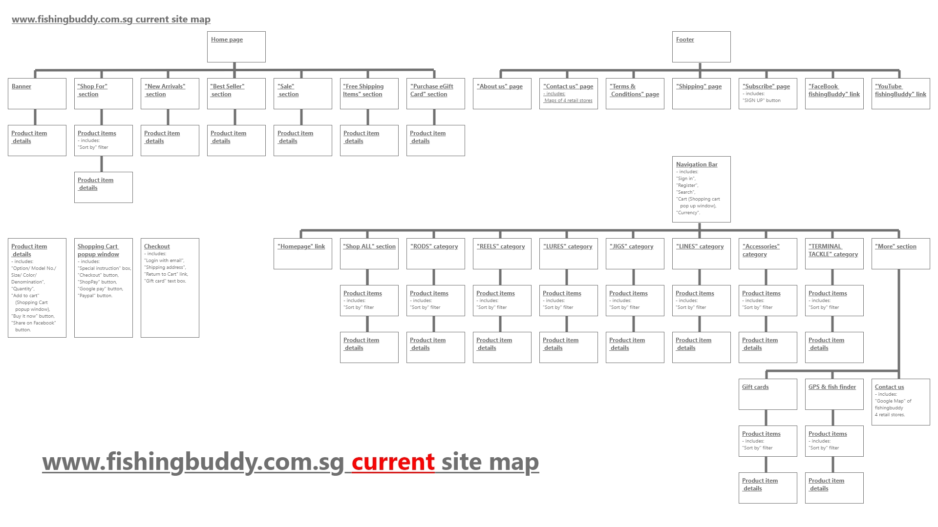

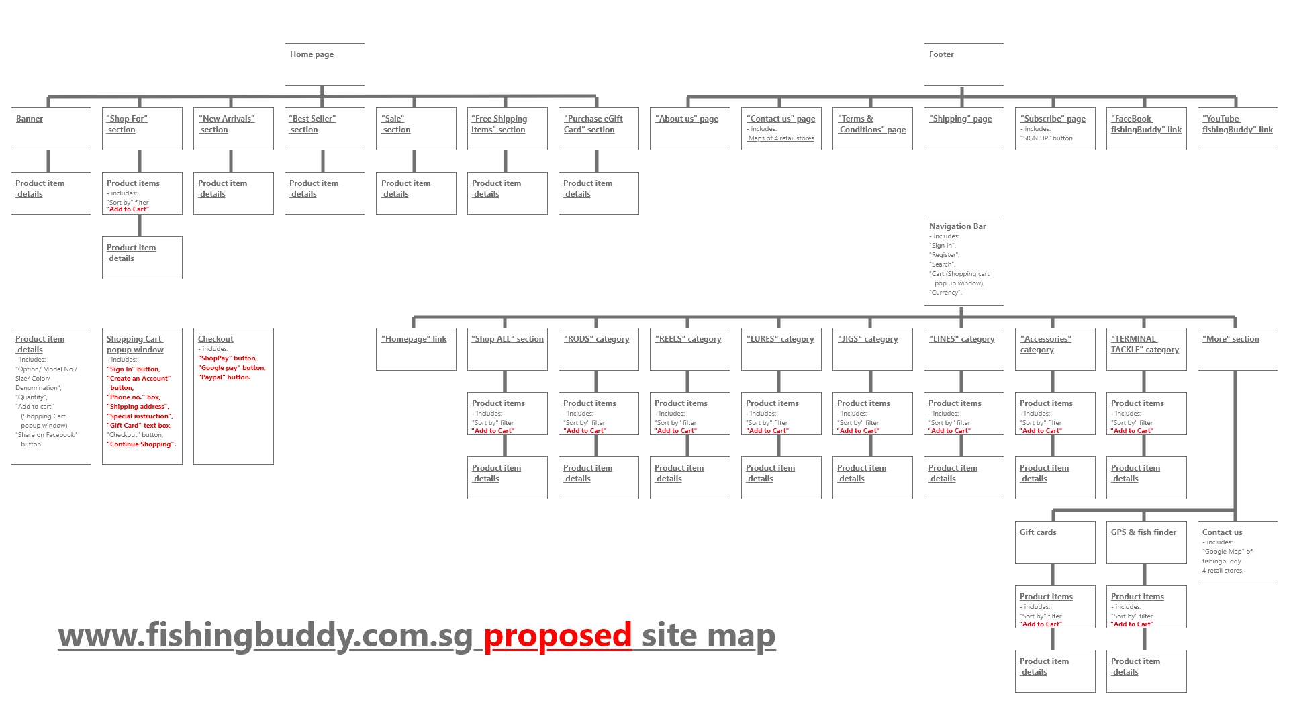

|  |  |  |  |  |  |
| --- | --- | --- | --- | --- | --- |
| Problems | Web pages has unnecessary Google text shown on top | Displays only a few items at a time. Have to click many buttons to see all the new arrival items | Product item details picture is too small, can be bigger | The Add to Cart page. Small fonts, lots of white background space, Cart pop up window exceeds screen page for just 2 items selected | Checkout page. Too crowded. Enter contact info / continue to shipping / 1 of the above payment services first? |
| Solutions | To hide “google tracking” text | To provide option in drop down list, to allow more display choices "number of items per page | To increase picture size to use up more of the empty page | To increase font size, minimize use of white empty background of Cart page | To simplify layout |

|  |  |  |  |  |  |
| --- | --- | --- | --- | --- | --- |
| Problems | Difficult to go to different web pages, Navigation bar is not easily available | Banner too big, occupy beyond screen page | Difficult to click on small page number buttons | No option to pay online, but collect at retail store | Like to see what others catch using fishingbuddy.com.sg equipment |
| Solutions | To fix Nav bar to top of every page | To reduce banner size to half of screen page | To increase “page number” buttons size | To provide option for self-collect at retail store after online payment | To include verbal testimonials from Users |

Revised User Journey: **Goh Trend** **(AFTER)**

|  |  |  |  |  |  |
| --- | --- | --- | --- | --- | --- |
| Happiness | Angel face outline with solid fill | Angel face outline with solid fill | Angel face outline with solid fill | Angel face outline with solid fill | Angel face outline with solid fill |
| Touch points | No more funny text at top of pages | New arrivals page, able to choose how many items to display at a time | Product description page picture size increased | Cart page, optimized font size & background empty space, changed layout, emphasis on items to pay, instead of contact info | Checkout page, simpler layout, just make payment only |
| Pain points | None | None | None | None | None |
| Support | None | None | None | None | None |

Revised User Journey: **Relax Joe** **(AFTER)**

|  |  |  |  |  |  |
| --- | --- | --- | --- | --- | --- |
| Happiness | Angel face outline with solid fill | Angel face outline with solid fill | Angel face outline with solid fill | Angel face outline with solid fill | Angel face outline with solid fill |
| Touch points | Easily accessible Nav bar at top of every page | Able to see more items with smaller banner picture | Bigger “page number” buttons for selection | Self-collect at retail store option provided | Like to see what others catch using fishingbuddy.com.sg equipment |
| Pain points | None | None | None | None | None |
| Support | None | None | None | None | None |

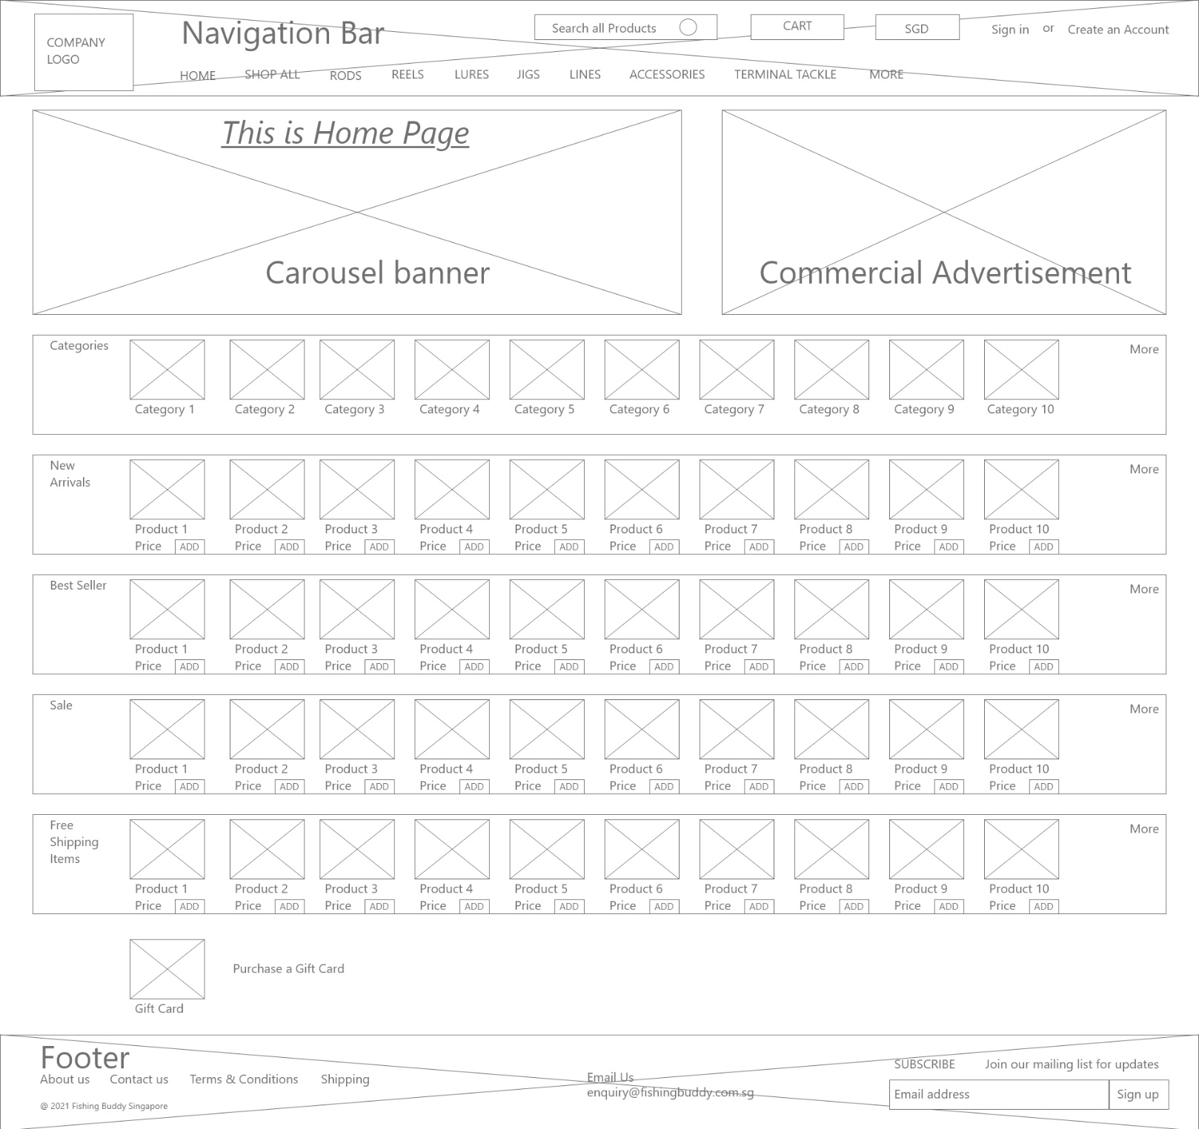

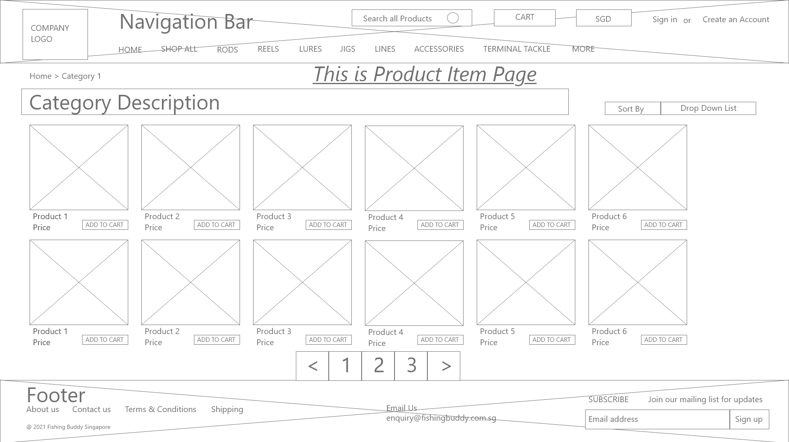

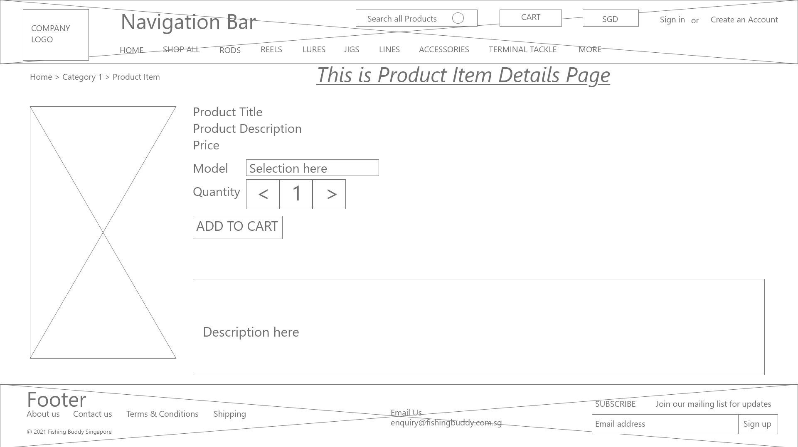

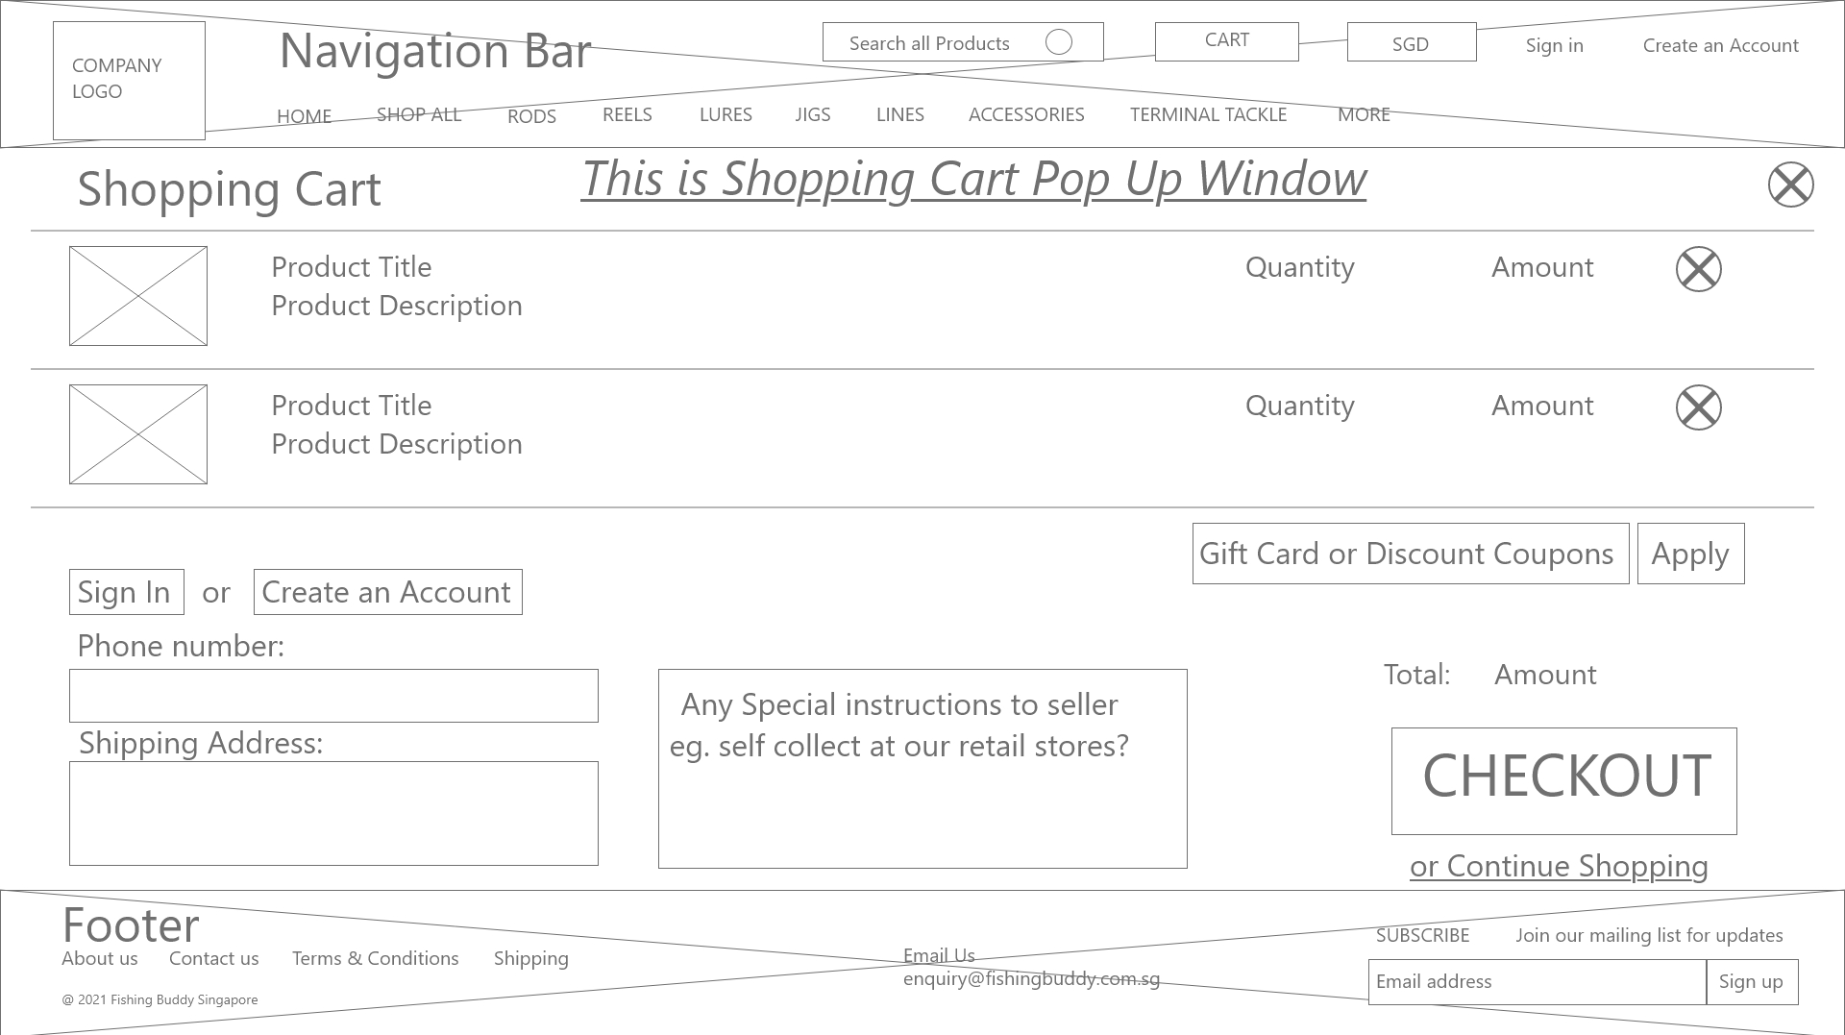

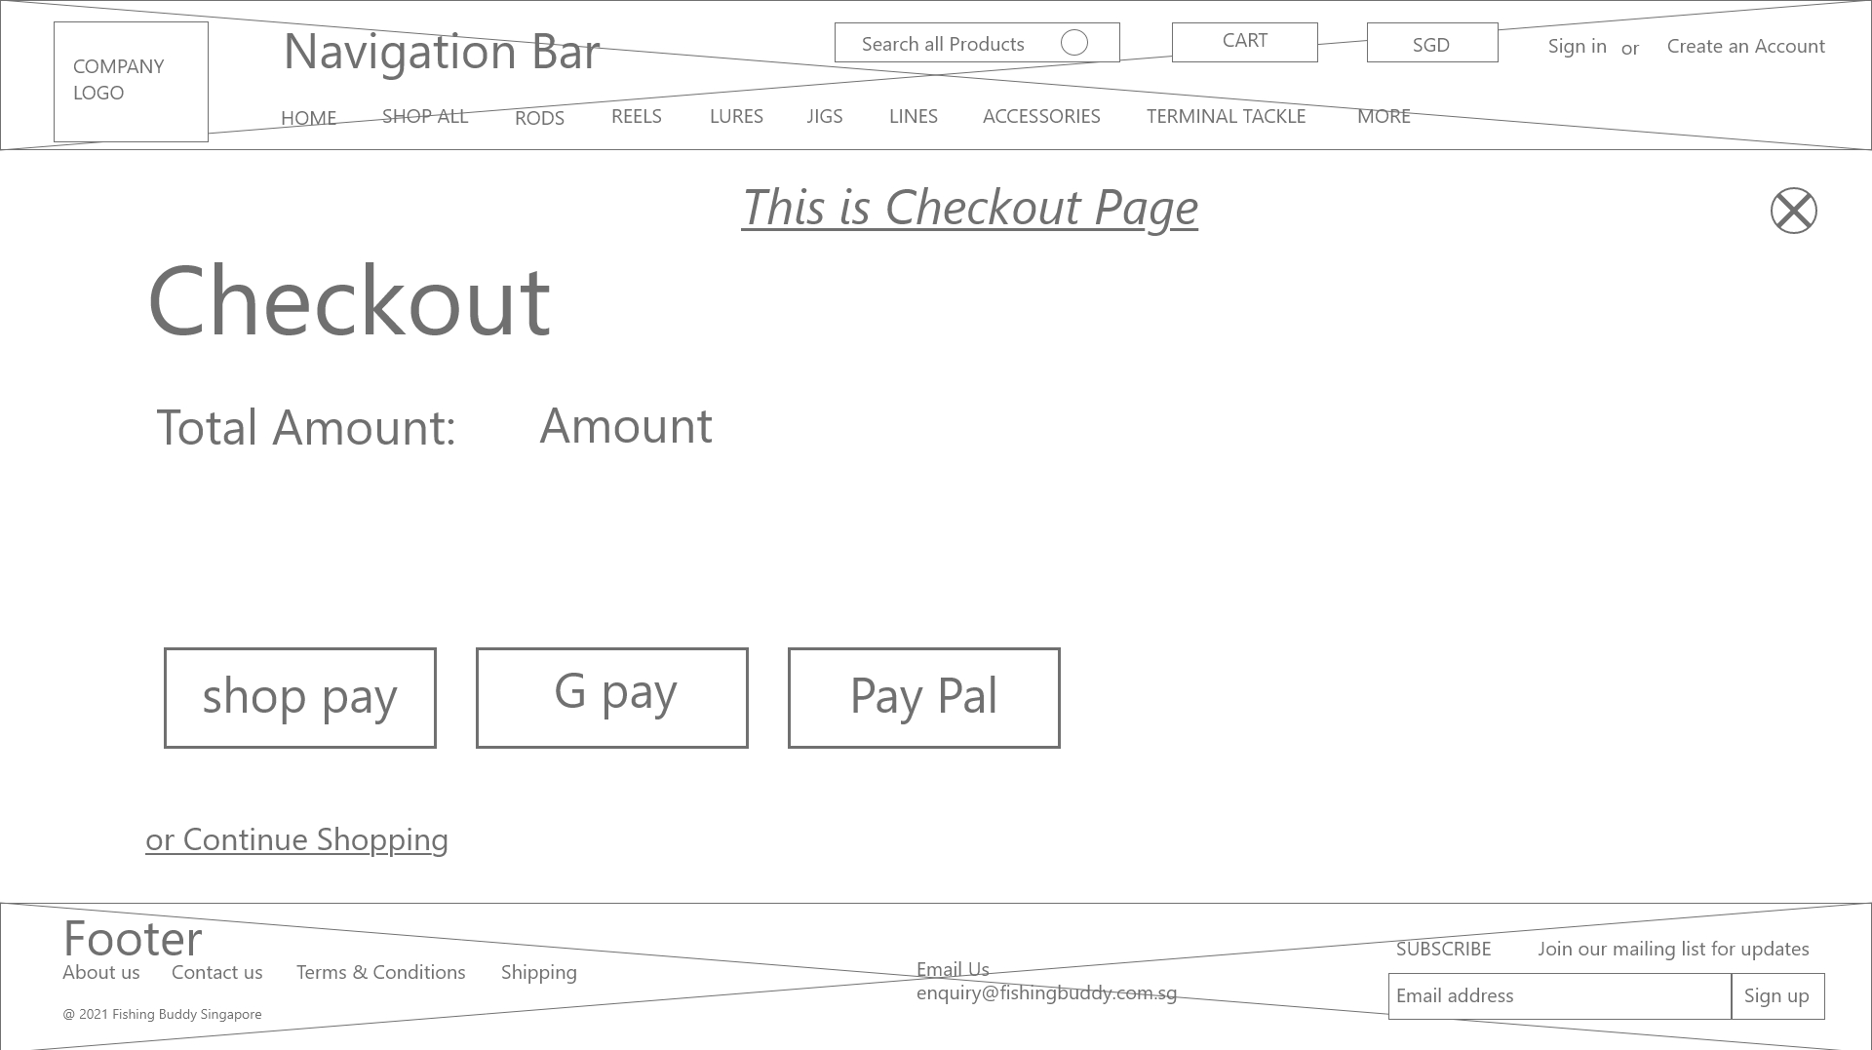

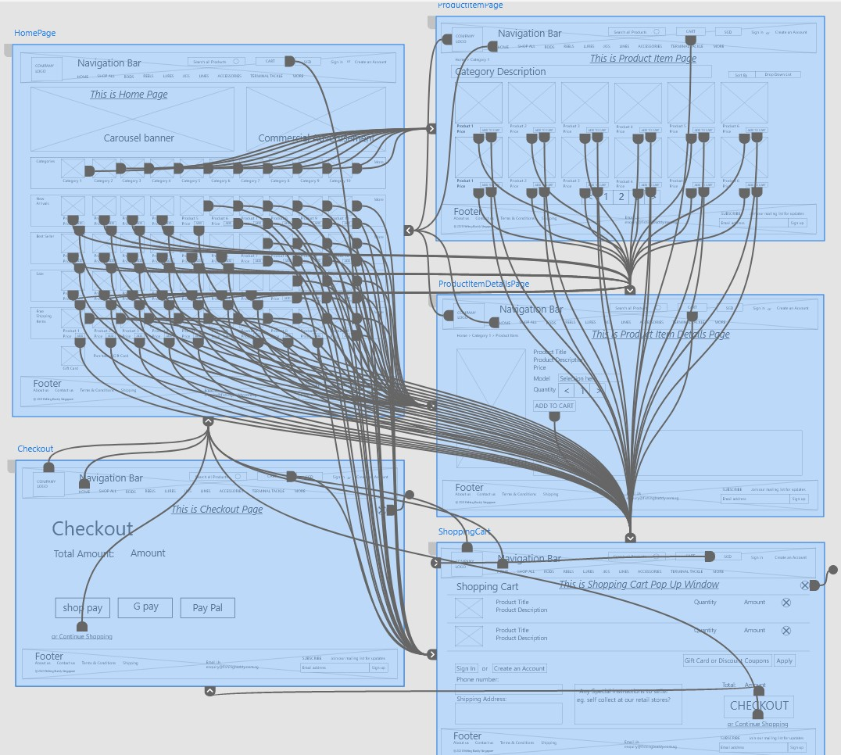

Wireframe Prototype of revamped [www.fishingbuddy.com.sg](http://www.fishingbuddy.com.sg) web site:

File:///d:/[vincentPrototypeDemo.mp4](../../../vincentPrototypeDemo.mp4)

(1 minute video recording)

Demonstrating User clicking on

* Category
* Product items page
* Product item details page
* Shopping Cart page
* Checkout page & back.

The End



**USER EXPERIENCE METHODS DESIGN**

**What The Fish**

www.fishingbuddy.com.sg

Persona: **Goh Trendy** Interviewees: RohdeeJon(20+), Jon(30-50), LimAhBay(30-50)

**Mr Rohdee Jon Bin Ahmad interview/ survey questions:**

1. Who are you?

a. Age group: 20 - 30 years,

b. What do you do for a living? eg. clerical, executive, management, home maker.

Administrative work.

2. Have you gone fishing before? Yes.

3. When do you usually go fishing? eg. weekends, holidays.

I try to make it once a month.

4. Who do you go fishing with usually? eg. family, friends, alone.

Friends.

5. Where do you usually buy fishing equipment & stuff from? eg. retail stores, online, name.

online. www.fishingbuddy.com.sg

6. How often do you shop online?

eg. everyday, once a week, once a month, whenever i feel like it.

Usually about the middle of every month.

7. What do you like/NOT like about shopping at www.fishingbuddy.com.sg?

They have many different fishing lures. I like to try different types just for the fun of it.

8. Is there any improvement that you would like to see at www.fishingbuddy.com.sg?

New products come in not fast enough, sometimes only 1 new product a month.

9. What would you like to see or buy from www.fishingbuddy.com.sg?

If the website can show me what other people buy also, maybe I can follow & learn something from other customers also.

Persona: **Goh Trendy** Interviewees: RohdeeJon(20+), Jon(30-50), LimAhBay(30-50)

**Mr Jon Tan interview/ survey questions:**

1. Who are you?

a. Age group: 31 - 49 years,

b. What do you do for a living? eg. clerical, executive, management, home maker.

salesman.

2. Have you gone fishing before? yes

3. When do you usually go fishing? eg. weekends, holidays.

About every quarter, take annual leave.

4. Who do you go fishing with usually? eg. family, friends, alone.

Friends.

5. Where do you usually buy fishing equipment & stuff from? eg. retail stores, online, name.

online, at www.fishingbuddy.com.sg.

6. How often do you shop online?

eg. everyday, once a week, once a month, whenever i feel like it.

Weekly.

7. What do you like/NOT like about shopping at www.fishingbuddy.com.sg?

They have a wide variety of fishing products.

8. Is there any improvement that you would like to see at www.fishingbuddy.com.sg?

They have funny words at the top of the website. Makes me feel like they are tracking me or something.

9. What would you like to see or buy from www.fishingbuddy.com.sg?

Fishing clothes.

Persona: **Goh Trendy** Interviewees: RohdeeJon(20+), Jon(30-50), LimAhBay(30-50)

Mr Lim Ah Bay interview/ survey questions:

1. Who are you?

a. Age group: 31 - 49 years,

b. What do you do for a living? eg. clerical, executive, management, home maker.

Business owner.

2. Have you gone fishing before? Yes.

3. When do you usually go fishing? eg. weekends, holidays:

Once a year.

4. Who do you go fishing with usually? eg. family, friends, alone.

Friends.

5. Where do you usually buy fishing equipment & stuff from? eg. retail stores, online, name.

Online, www.fishingbuddy.com.sg.

6. How often do you shop online?

eg. everyday, once a week, once a month, whenever i feel like it.

Maybe 3 or 4 times a year.

7. What do you like/NOT like about shopping at www.fishingbuddy.com.sg?

Easy to see the pictures, choose & pay.

8. Is there any improvement that you would like to see at www.fishingbuddy.com.sg?

Have to open many pages to see all the items. Best, if can let me choose, say i want to see 100 items, all at the same time, in 1 page, then I don't need to open page after page.

9. What would you like to see or buy from www.fishingbuddy.com.sg?

Discounts. Can save more money.

Persona: **Relax Joe** Interviewees: Raymond (50+) & TanYimChi

Mr Raymond Goh interview/ survey questions:

1. Who are you?

a. Age group: above 50 years.

b. What do you do for a living? eg. clerical, executive, management, home maker.

Retiree.

2. Have you gone fishing before? Yes.

3. When do you usually go fishing? eg. weekends, holidays.

Usually weekends.

4. Who do you go fishing with usually? eg. family, friends, alone.

Friends.

5. Where do you usually buy fishing equipment & stuff from? eg. retail stores, online, name.

Both retail & online from www.fishingbuddy.com.sg.

6. How often do you shop online?

eg. everyday, once a week, once a month, whenever i feel like it.

Whenever I feel like it, sometimes everyday.

7. What do you like/NOT like about shopping at www.fishingbuddy.com.sg?

They have very beautiful & colourful pictures in here.

8. Is there any improvement that you would like to see at www.fishingbuddy.com.sg?

The number boxes (at the bottom of the page) to go to different product pages are quite small. Difficult to point with finger.

Moving from page to page is not easy, need to go back all the way to the top of the page

then can go to other pages.

9. What would you like to see or buy from www.fishingbuddy.com.sg?

If other customers can post what they catch, using what things (equipment), then will be more interesting.

Persona: **Relax Joe** Interviewees: Raymond (50+) & TanYimChi

Mdm Tan Yim Chi interview/ survey questions:

1. Who are you?

a. Age group: above 50 years.

b. What do you do for a living? eg. clerical, executive, management, home maker.

House wife. Tai-Tai, because husband already earn alot of money.

2. Have you gone fishing before? Yes.

3. When do you usually go fishing? eg. weekends, holidays.

Sometimes 3 times a year.

4. Who do you go fishing with usually? eg. family, friends, alone.

Friends. Get away from husband.

5. Where do you usually buy fishing equipment & stuff from? eg. retail stores, online, name.

Both retail & online at www.fishingbuddy.com.sg.

6. How often do you shop online?

eg. everyday, once a week, once a month, whenever i feel like it.

Everyday, very free at home.

7. What do you like/NOT like about shopping at www.fishingbuddy.com.sg?

Reasonable prices, local company, they also have retail store, so won't cheat our money.

8. Is there any improvement that you would like to see at www.fishingbuddy.com.sg?

The main page picture is so big, every time I need to scroll down the screen just to see the items.

9. What would you like to see or buy from www.fishingbuddy.com.sg?

Good if I can order online, pay online, they reserve for me, then I go collect from their retail store.

So I no need to register my details online; troublesome.

The [www.fishingbuddy.com.sg](http://www.fishingbuddy.com.sg) website has changed since I started working on revamping it.

This is a snapshot of the original website:



